**Background Study:**

The hostel management system is web based system to provide hostel. The software will be great relief to the employees. This system also keeps details of the hostellers and applied borders. Its automatically select the students from the mess calculation, complaint registration, notice board etc.

**Features:**

* Borders login
* Admin login
* Registration option
* Room chooses & availability factuality
* Dyning Management system
* Online hotel system saves time spent on manual updates
* Access to a single dashboard to control all functions

**Gantt chart:**

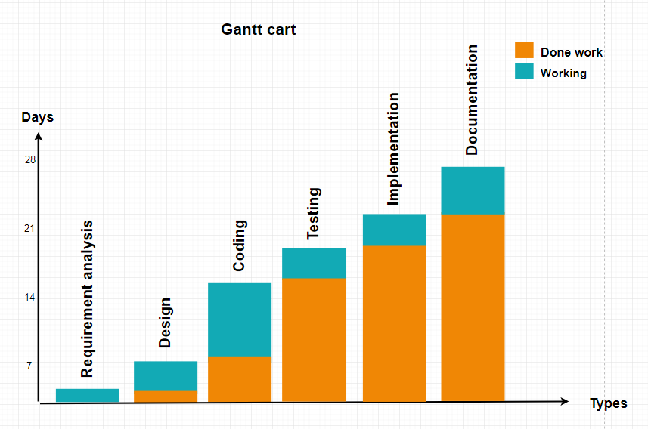

**Software Requirements**

* XAMPP server
* **Language Used**
  1. **Front End(User Interface)**HTML 5 , CSS,JAVASCRIPT
  2. **Server Language** PHP
  3. **Back End**MYSQL

**Data flow diagram:**

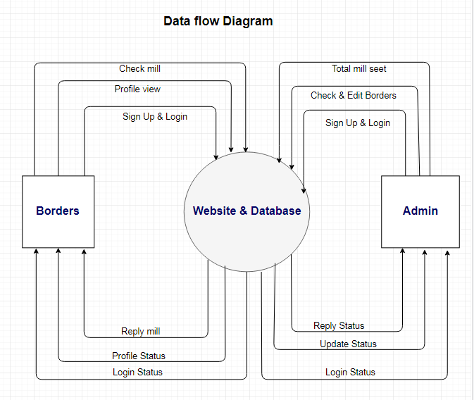

**Document flow diagram:**

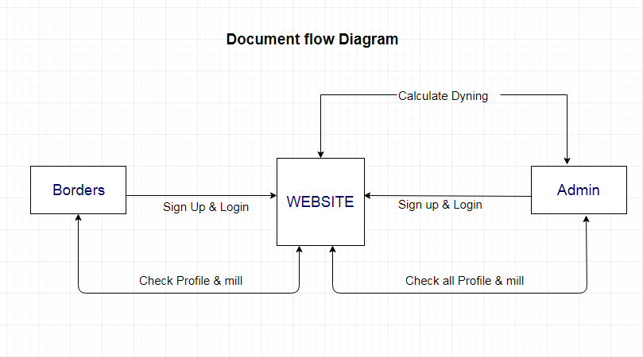

**Contribution:**

The existing system is manual based and need lot of efforts and consume enough time. In the existing system we can apply for the hostels online.

**Conclusion:**

To conclude the description about the project developed using PHP with MySQL. It’s based on the requirement specification of the user and analysis of the existing system, with flexibility for future enhancement. Online HOSTEL MANAGEMENT SYSTEM is very useful for mess fee calculation.